# Change Requirements for Phase I

Please mark up each chart individually (pencils, colored markers, etc.) with the changes you’d like to see.

## Hourly Generation

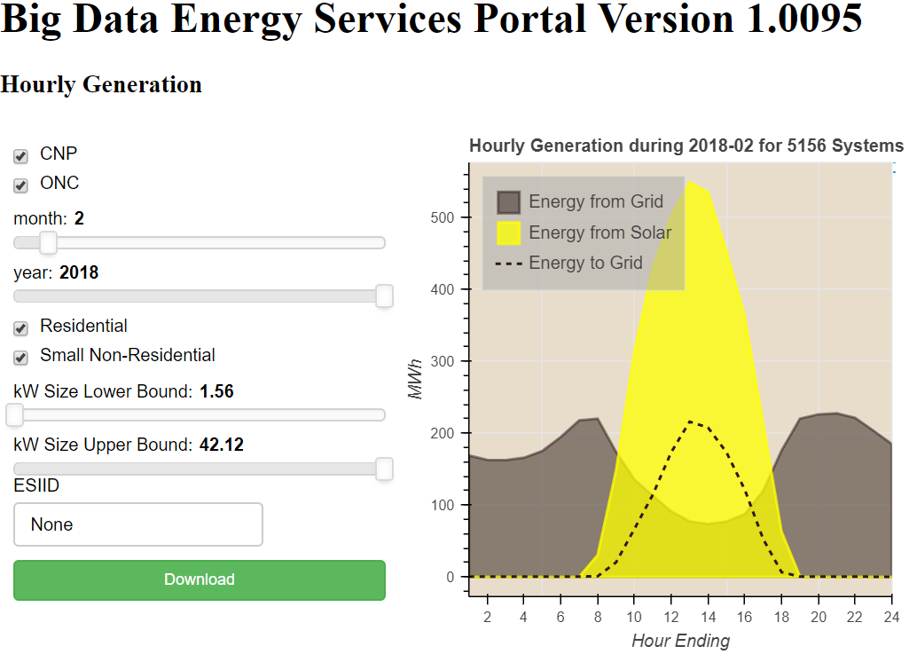

## Hourly Cash Flow

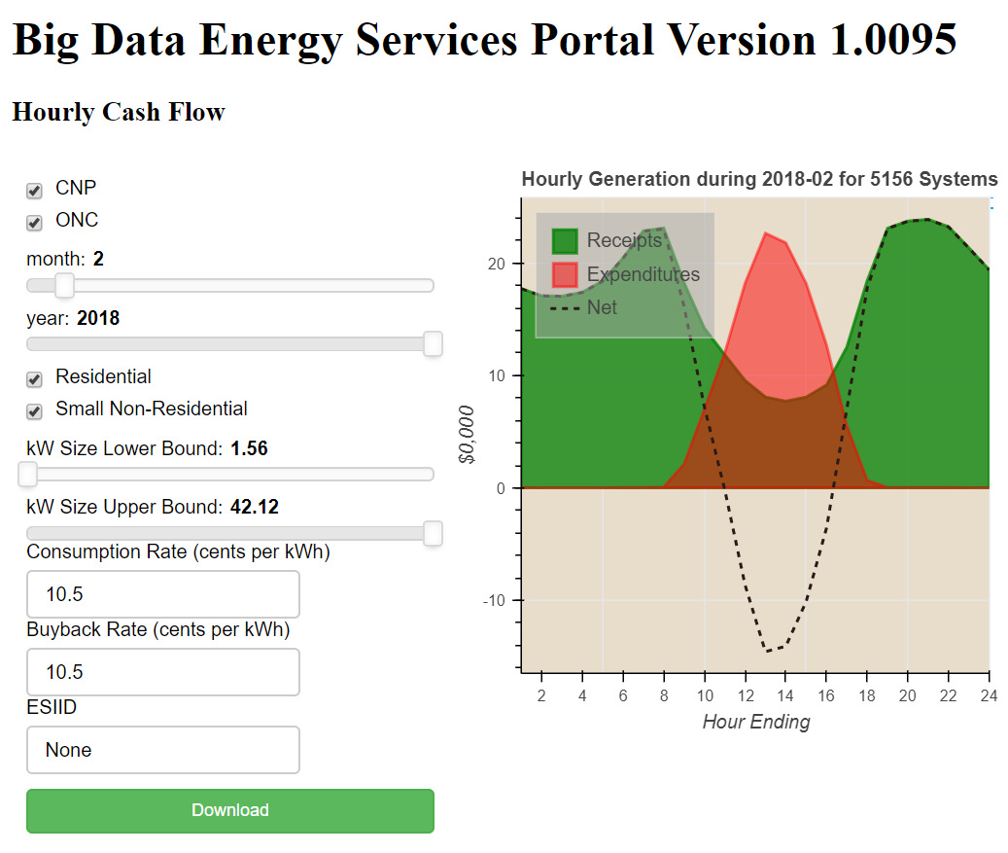

1. We need labels or something that shows this is hourly aggregated data based on SMT for others not familiar with development.
   1. BDES: Please label and title the graph how you’d like to see it, and we’ll replicate it.
2. We need the numbers behind this visual as it’s hard to interpret from the graph.
   1. BDES: Please label and title the graph how you’d like to see it, and we’ll replicate it.

## Monthly Cash Flow

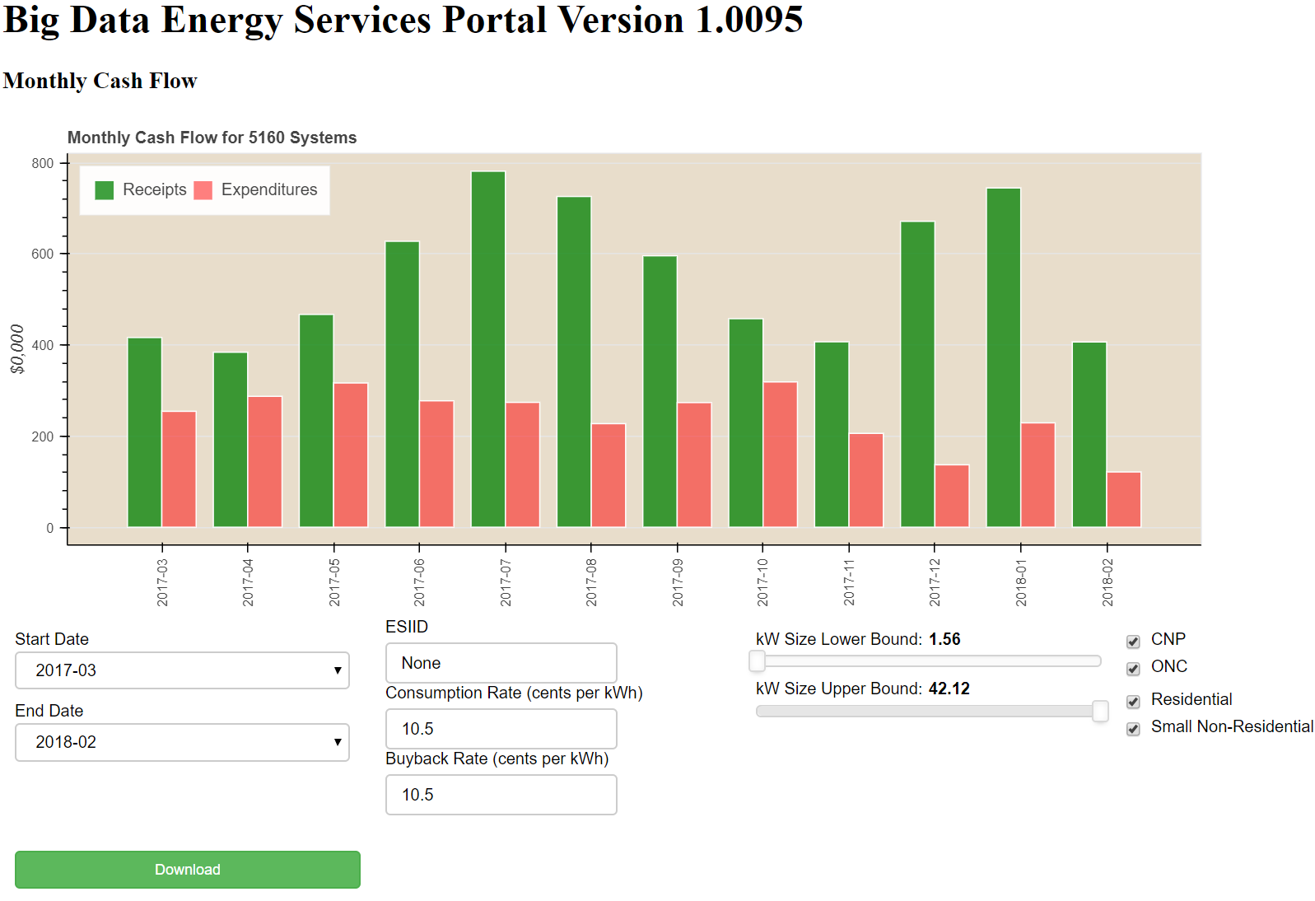

## Cash Waterfall

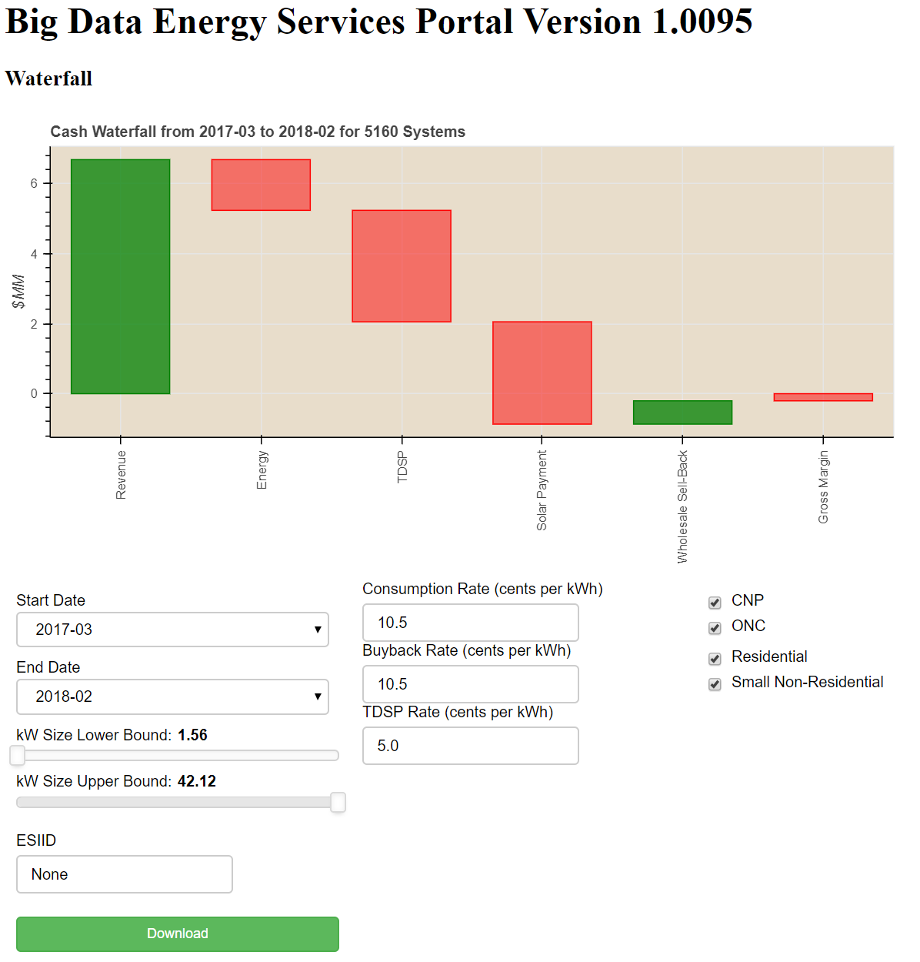

1. Can we combine the wholesale sell-back with Energy as discussed and change TDSP to TDU in all areas of the app?
   1. BDES: Please label and title the graph how you’d like to see it, and we’ll replicate it.

## Revenue Ranking

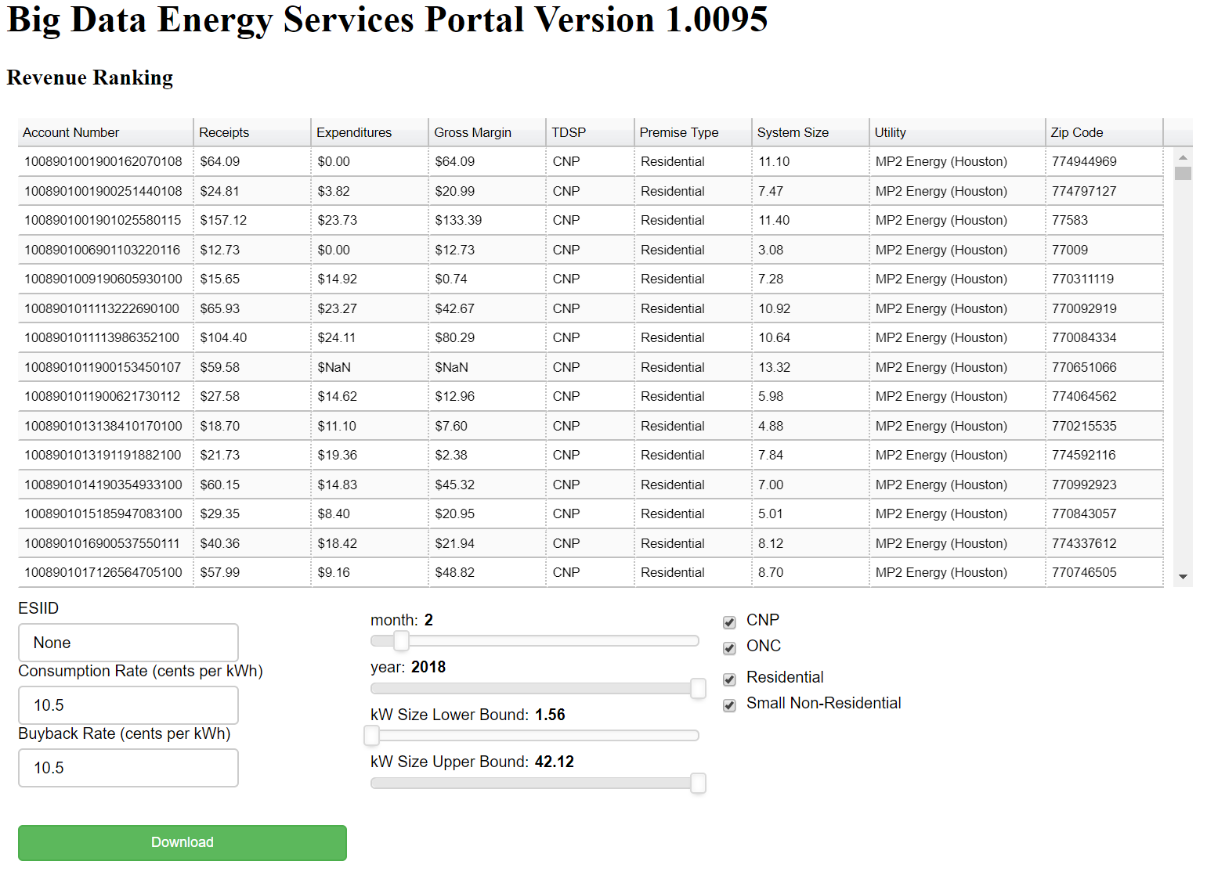

1. Can we change the $NaN to $0? Also, wouldn’t there still associated margin? Why does this show $NaN as well.
   1. BDES: NAN means “not a number”. If Expenditures is missing then that means there is no GenerationCode=1 for this ESIID for this month. We can override that with 0 at your request, but that means you might be covering up data feed errors. And if expenditures is NAN, then Gross Margin will also be NAN since it’s a function of Receipts and Expenditures

## Solar Ranking

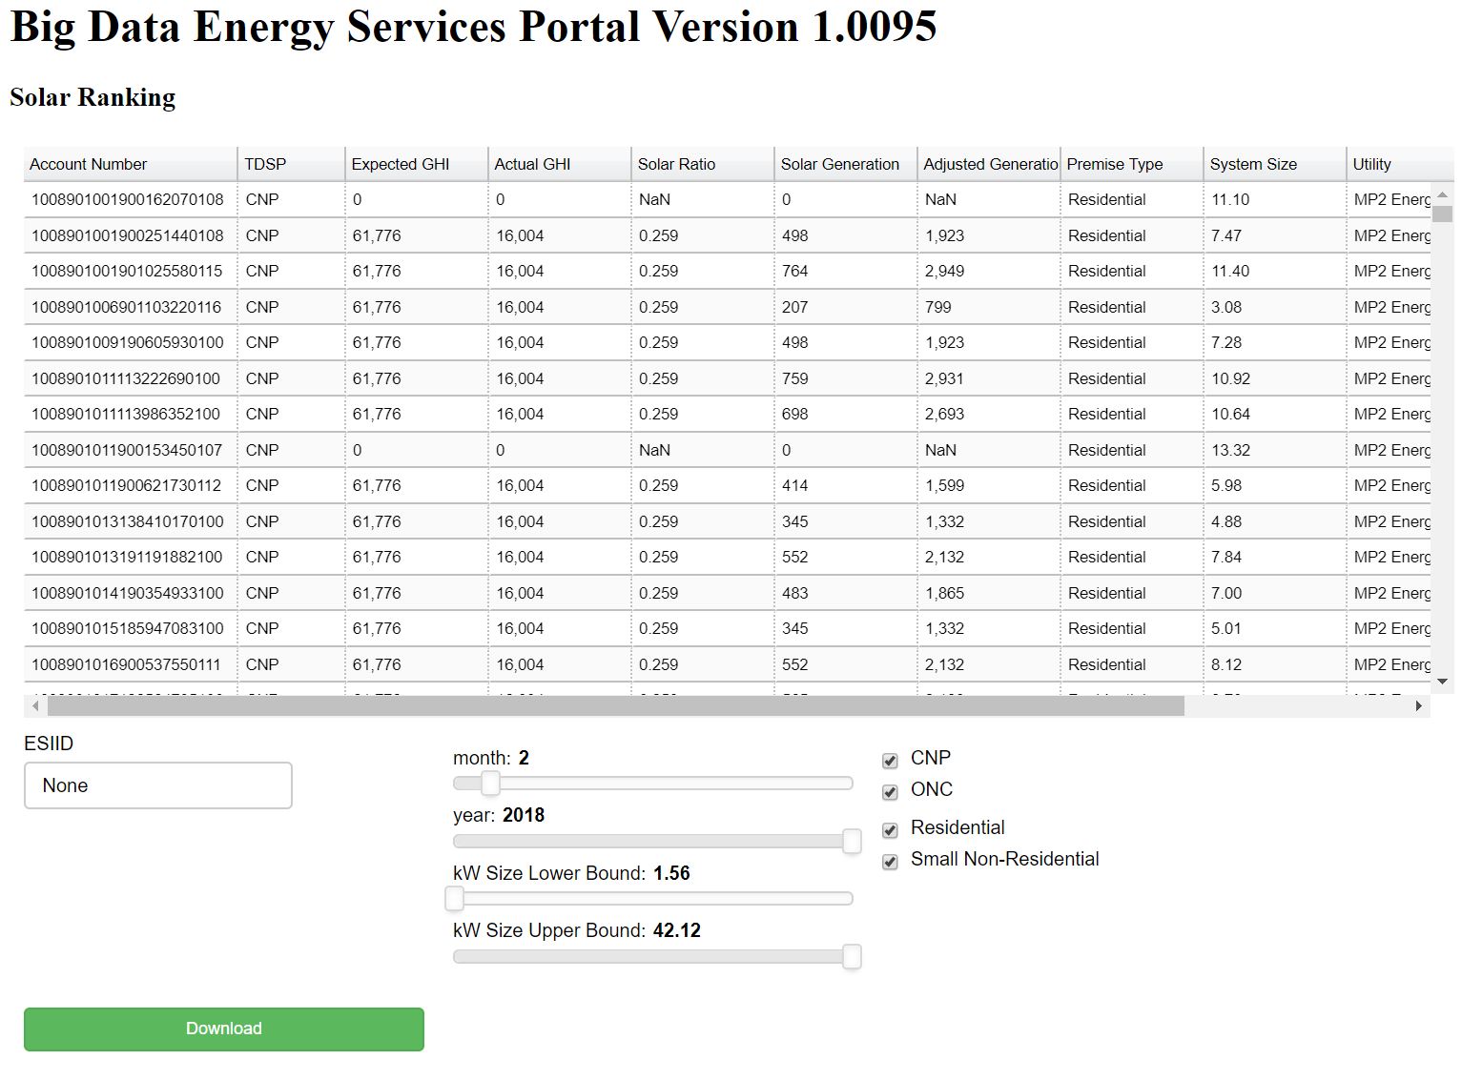

## Other Change Request

1. The downloadable data needs to be formatted. ESIIDs, $ symbols, etc.
   1. BDES: Please attach example CSV files for each chart and we will replicate the format.
2. We need to agree on a solution for updating the data monthly. Maybe we just send you an updated spreadsheet each month or we can post to a ShareFile?
3. We really need to be able to pull data for any desired date range for each section. Could we carve out a daily snapshot in addition to the monthly aggregated on a per customer level? Can we take a look at one EZ to see how that would look?
   1. 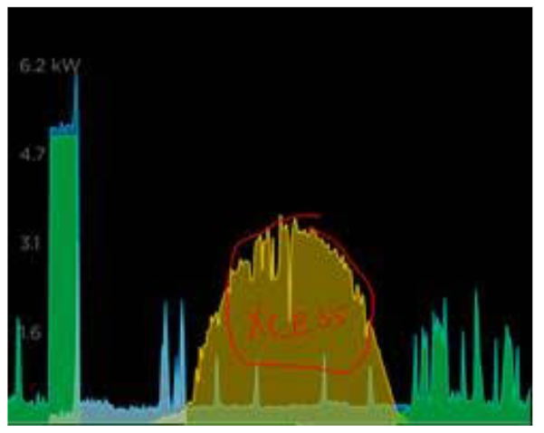
   2. BDES: This is an ideal candidate for Phase II
4. Also, the ability to show annual and seasonal i.e. Jan-Dec, Jan-Mar, etc. Maybe on a sliding scale like the average monthly?
   1. BDES: Please mark up each graph to show how you’d like to implement this functionality
5. This also need needs to apply to the other sections i.e Hourly Generation, Hourly Cash Flow, etc. so we can see seasonal trends. Both levels – portfolio and customer.
   1. BDES: Please mark up each graph to show how you’d like to implement this functionality